CSC 157

Name __James Aniciete______________

Date ___2/21/2020_______________

Lab No. ___05____

Purpose of the Lab Activity

**The purpose of this lab activity is to use functions and random number generators via the random module to create a pick 3 lottery game.**

Source Code

# Programmer: James Aniciete

# Course No.: CSC 157

# Lab 05: Lottery Game

# Date: 2/20/2020

# import random module

import random

# use seed of 0 to allow correct answer output

random.seed(0)

# variable initializations & declarations

# integers

num1 = 0

num2 = 0

num3 = 0

# lists

numbers = []

winners = []

sortedNumbers = []

sortedWinners = []

# ask user for 3 numbers

print("Enter 3 different integers [0, 9] to play.")

num1 = int(input("Enter first number: "))

num2 = int(input("Enter second number: "))

num3 = int(input("Enter third number: "))

print("\n")

# while loop to ensure unique numbers are entered

while (num1 == num2) or (num1 == num3) or (num2==num3):

print("The three numbers must be unique. Try again.")

num1 = int(input("Enter first number: "))

num2 = int(input("Enter second number: "))

num3 = int(input("Enter third number: "))

print("\n")

# append numbers into a list with a for loop

for i in [num1, num2, num3]:

numbers.append(i)

# generate the unique winning numbers

winners = list(random.sample(range(0,10), 3))

# use function to sort numbers & winners

sortedNumbers = sorted(numbers)

sortedWinners = sorted(winners)

# display message to tell user if they won

if sortedNumbers == sortedWinners:

print("Congratulations, you have won $100!")

else:

print("Nice try, better luck next time around!")

# display the sorted entered numbers & winning numbers

print("The winning numbers were: ", winners[0], winners[1], winners[2])

print("Your numbers were: ", numbers[0], numbers[1], numbers[2])

Snippet(s) of Output(s)

**Loss examples without random.seed(0):**

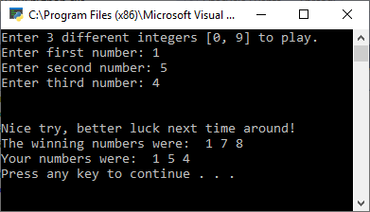

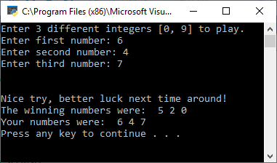

**Loss with random.seed(0):**

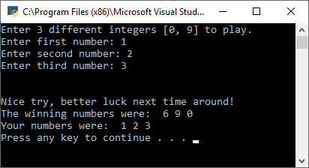

**Duplicate Number + Win with random.seed(0):**

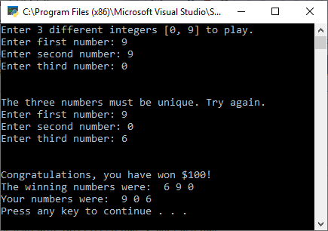

Extra Credit - Modified Source Code

# Programmer: James Aniciete

# Course No.: CSC 157

# Lab 05: Lottery Game

# Date: 2/20/2020

# import random module

import random

# use seed of 0 to allow correct answer output

random.seed(0)

# display welcome message

print("Welcome, you have three chances to Pick 3 and win.")

#give the user 3 attempts to guess the winning numbers correctly

for i in range(3):

# variable initializations & declarations

# string for playing Fireball or not

style = ""

# integers

num1 = 0

num2 = 0

num3 = 0

fireball = 0

# lists

numbers = []

choices = [] # stores all choices for a winning combination

winners = [] # contains 3 winning numbers

sortedNumbers = []

sortedChoices = []

# four possible combinations for winning with Fireball number

combos = [] # will contain winners1-4 as sublists

winners1 = []

winners2 = []

winners3 = []

winners4 = []

# stores winning combination

winningCombo = []

# Boolean

fireballWinner = False

# ask user if playing Fireball

style = input("Would you like to play Fireball (Y/N)? ")

print("\n")

# ensure entry was valid

while (style != "Y") and (style != "N"):

style = input("Invalid entry. Would you like to play Fireball (Y/N)? ")

print("\n")

# ask user for 3 numbers

print("Enter 3 different integers [0, 9] to play.")

num1 = int(input("Enter first number: "))

num2 = int(input("Enter second number: "))

num3 = int(input("Enter third number: "))

print("\n")

# while loop to ensure unique numbers were entered

while (num1 == num2) or (num1 == num3) or (num2 == num3):

print("The three numbers must be unique. Try again.")

num1 = int(input("Enter first number: "))

num2 = int(input("Enter second number: "))

num3 = int(input("Enter third number: "))

print("\n")

# append numbers into a list with a for loop

for i in [num1, num2, num3]:

numbers.append(i)

# sort the numbers list

sortedNumbers = sorted(numbers)

if style == "Y":

# generate list of unique winning numbers and the fireball number, the 4th number from the sample

choices = list(random.sample(range(0,10), 4))

# make list of winning numbers

# slice uses an interval similar to range

winners = choices[slice(0,4)]

# store fireball number

fireball = choices[3]

# sort choices

sortedChoices = sorted(choices)

# make a list containing each possible combination of winning numbers

# sublist containing elements 1-3

winners1 = sortedChoices[0:3]

# contains elements 2-4

winners2 = sortedChoices[1:4]

# contains elements 1, 2, 4

winners3.extend(sortedChoices[0:2])

winners3.append(sortedChoices[3])

# contains elements 1, 3, 4

winners4.append(sortedChoices[0])

winners4.extend(sortedChoices[2:4])

# put sublists into a list

combos = [winners1, winners2, winners3, winners4]

print("Your possible combinations: ", sep ="")

print(*combos, sep =", ")

# if there is a winning combo, set Boolean variable to True & assign it to winningCombo

for i in combos:

if sortedNumbers == i:

fireballWinner = True

winningCombo = i

# if user won, display the sorted entered numbers & winning numbers

if fireballWinner == True:

print("Congratulations! You have won $150 for playing Fireball Pick 3!")

print("You won with the combination: ", winningCombo[0], winningCombo[1], winningCombo[2])

else:

print("Nice try, better luck next time around!")

print("The winning numbers were: ", winners[0], winners[1], winners[2])

print("The Fireball number was: ", fireball)

print("Your numbers were: ", numbers[0], numbers[1], numbers[2])

else:

# generate the unique winning numbers

winners = list(random.sample(range(0,10), 3))

# use function to sort numbers & winners

sortedNumbers = sorted(numbers)

sortedWinners = sorted(winners)

# display message to tell user if they won

if sortedNumbers == sortedWinners:

print("Congratulations, you have won $100 playing Pick 3!")

else:

print("Nice try, better luck next time around!")

# display the sorted entered numbers & winning numbers

print("The winning numbers were: ", winners[0], winners[1], winners[2])

print("Your numbers were: ", numbers[0], numbers[1], numbers[2])

print("\n")

Extra Credit - Snippet(s) of Output(s) from execution of modified Code

**Invalid string+ duplicate + incorrect Pick 3, incorrect Fireball Pick 3, correct Fireball Pick 3:**

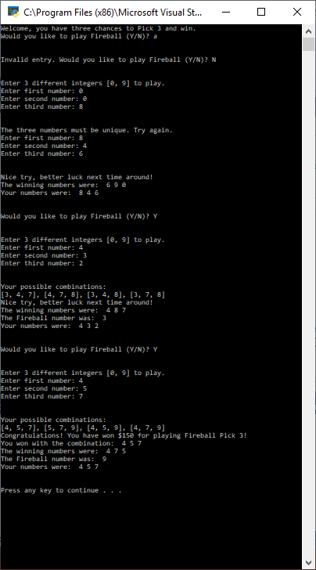

**Correct Fireball Pick 3, Correct Pick 3, Inorrect Fireball Pick 3:**

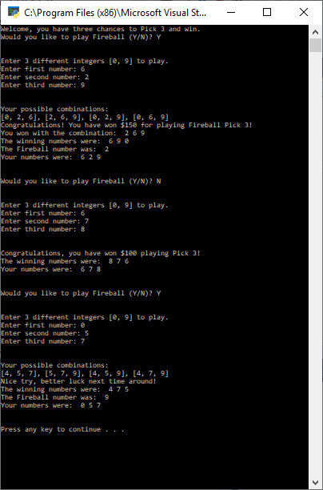

Excel Spreadsheet (when Calculations are involved)

**n/a**

Answers to Questions (Be sure to copy the questios themselves!)

**(1)** Describe the output of this code segment.

**import random**

**list = sorted(random.sample(range(1, 13), 4))**

**for count in range(len(list)) :**

**print (" random number: ", list[count])**

**The output of this code segment will display four randomly sampled numbers in the range [1, 12]**

**(2)** Describe the output of this code segment.

**def result(arg1, arg2) :**

**answer = 2 * arg1 – 3 * arg2**

**print ("inside the function body : ", answer)**

**return answer;**

**print (result(-3, 11))**

**This code calls the result function, where arg1 = -3 and arg2 = 11. Thus, answer = 2 * -3 -3 * 11 = -39. This code will print “inside the function body : -39” first. Then it will return the answer, -39.**

**(3)** Explain how you write a program that would sort three whole numbers?

**You would define a function with three integer arguments, put the integers into a list, call the sorted function on the list, and then reassign the variables in ascending order, using list indices. This could look like:**

**def sorter(a: int, b: int, c: int):**

**l = []**

**l = [a,b,c]**

**l = sorted(l)**

**a = l[0]**

**b = l[1]**

**c = l[2]**

**print(a, b, c)**

**(4)** In the realm of lottery games, what is meant by a Powerball?

**A Powerball is used to allow for two drums to draw winners in lottery games, where one drum is used for the five white balls from 1 to 69 and one for the red Powerball from 1 to 26. One can add the PowerPlay option, “which increases the size of your prize if you correctly guess one to five qualifying numbers.” Essentially, the Powerball allows for higher payouts.**

**See:** <https://www.thebalanceeveryday.com/how-powerball-works-896649>

**(5)** What have you learned from performing and coding for this lab assignment?

**I have learned how to work with lists, sublists, and the random module better. Specifically, I learned how to define data types in function definitions, how to use the slice() and sort() functions, and how to work with sublists using the extend and append methods.**